**AHMED HAMED ALY**

18308279

DATE: 12/OCT/2018

LAB: LG35/36

TIME: 4PM TO 6PM

**Introduction**

The experiment consisted of three main parts,

(A) Connecting a circuit using the circuit diagram provided in the question;

(B) Using a 5 volts d.c. supply to measure the voltage drop of the resistors and LED and the current running through the resistors and the LED;

(C) Connecting the circuit to parallel resistors and observing the change to the light as the resistance is increased.

There was a couple of factors I had to take into account before starting the experiment. These included,

Using working apparatus that has been tested before and won’t cause an error in my result;

Made sure I could identify resistor values by looking up a chart of the colour coded resistors and linking it up with the resistors provided;

Understood the different symbols that are presented on the circuit diagram in the question. The most important of these symbols are (shown below)

C:\Users\hamedala\AppData\Local\Microsoft\Windows\INetCache\Content.Word\Resistor-Circuit-Symbol.jpg



**Resistor Light Emitting Diode**

**Objective**

The objective of the experiment is to verify Kirchoff’s Current and Voltage laws.

Kirchoff’s Current law states that the sum of all currents flowing into a node is zero and the sum of all currents leaving a node is also zero. In the image below the sum of currents IB, IC and ID are equal to IA

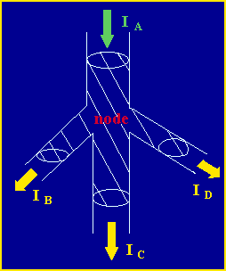

Kirchoff’s Voltage law states that the sum of all voltage drops and rises in a closed loop is equal to zero. In the image below the sum of all the voltages in loop 1 and 2 of the closed circuit is equal to zero.

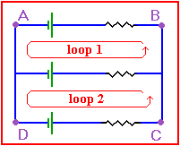

**Apparatus**

The apparatus used for the experiment (shown below) were vital to producing the results I acquired from the experiment.

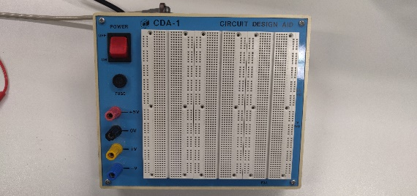 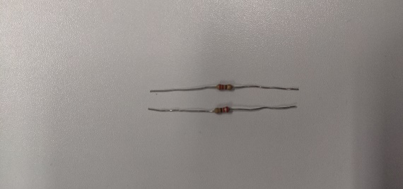

Breadboard 2 x 220 ohms resistors

 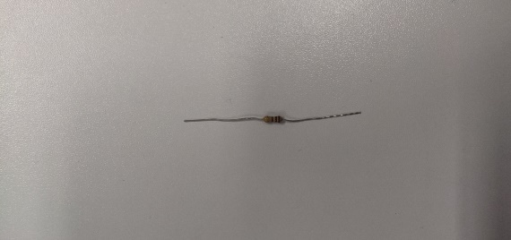

Light Emitting Diode (LED) 100 ohms resistor

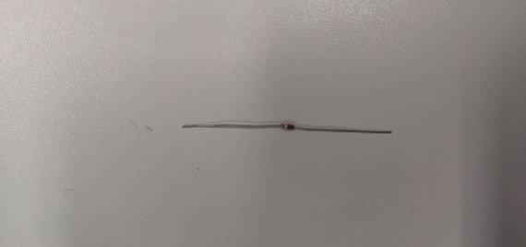 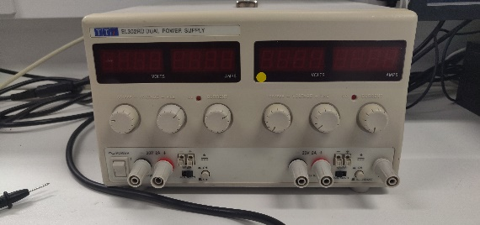

50 ohms resistor Power Supply

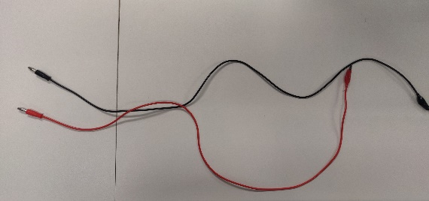 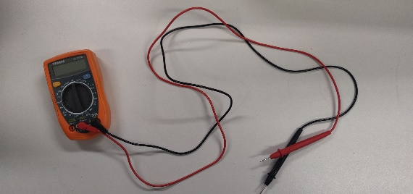

Wires Multi-meter

**Method**

1. Connect the circuit (**CIRCUIT 1**) in the diagram shown below.

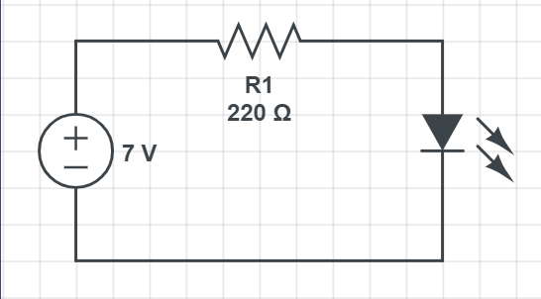

1. Using a 5V D.C. voltage measure the voltage drop across the LED and the resistor and also the current through the LED and resistor using a multi-meter and record your measurements.
2. Connect the circuit (**CIRCUIT 2**) in the diagram show below with different configurations for R2.

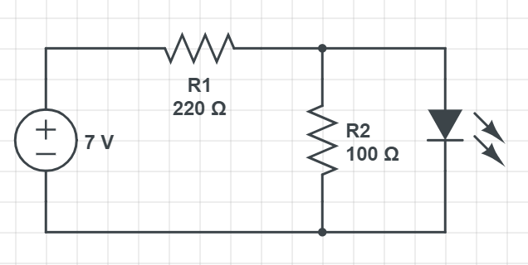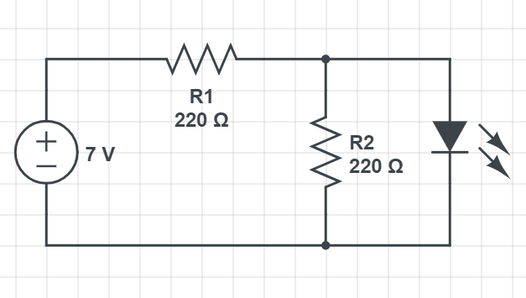

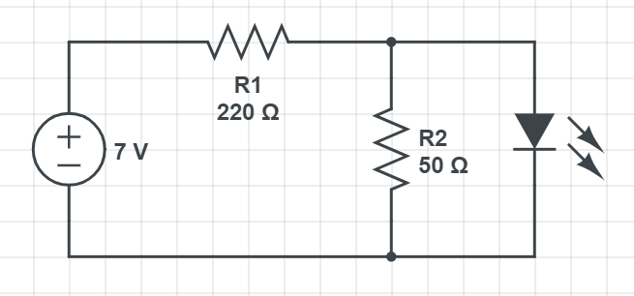

Configuration 1 Configuration 2 Configuration 3

1. Using a 7V voltage measure the voltage drop across the LED and R1 and R2 for each configuration and also the current through the LED and R1 and R2 for each configuration using a multi-meter and record your measurements.

**Data**

**Circuit 1:**

|  |  |  |
| --- | --- | --- |
| ||||||||||||||||||||||||||||||||||||||||||||||| | Voltage drop | Current through |
| LED | 1.37V | 22.9mA |
| Resistor 1 | 3.64V | 10.5mA |

**Circuit 2:**

50 Ohms resistor: **Barely lit up**

|  |  |  |
| --- | --- | --- |
| |||||||||||||||||||||||||||||||||||||||||||||| | Voltage drop | Current through |
| LED | 5.7V | 31.3mA |
| Resistor 1 | 1.35V | 150.7mA |
| Resistor 2 | 5.7V | 31.3mA |

100 Ohms resistor: **Half lit up**

|  |  |  |
| --- | --- | --- |
| |||||||||||||||||||||||||||||||||||||||||||||| | Voltage drop | Current through |
| LED | 4.9V | 31.5mA |
| Resistor 1 | 2.14V | 86.1mA |
| Resistor 2 | 4.9V | 31.6mA |

220 Ohms resistor: **Fully lit up**

|  |  |  |
| --- | --- | --- |
| |||||||||||||||||||||||||||||||||||||||||||||| | Voltage drop | Current through |
| LED | 3.98V | 32mA |
| Resistor 1 | 3.06V | 48.5mA |
| Resistor 2 | 3.98V | 32.1mA |

**Data Analysis**

From my results I observed that the 50 0hms resistor barely made the LED light up while the 100 ohms resistor made the LED half lit while the 220 ohms resistor made the LED light up fully. This is due to all the current is flowing through the 50 ohms rather than going to the LED while the 220 ohms resistor all the current went through the LED rather than the resistor. This demonstrates the basic aspects of how a DC circuit in the configuration of a parallel circuit works.

Kirchoff’s Voltage law is demonstrated in the data above due to the voltage drop of the circuit follows the equation:

VS = IR1 + IR2

VS = I(R1 + R2)

VS = IRT

Where: RT = R1 + R2

∴ 7V ≈ 4.9V + 2.14V

The voltage drop across the LED and the second resistor is the same in each case. According to Kirchoff’s voltage law, the total voltage drop in the external circuit is equal to the gain in the voltage as a charge passes through the internal circuit. The current flowing through the LED, when the second resistor has a resistance of 50 ohms and 100 ohms followed my hypothesis as I expected because the LED barely lit up for the 50 ohms and half lit up for 100 ohms while the 220 ohms allowed the LED to light up fully since the current had an easy path by going through the LED path rather than the 220 ohms resistor.

**Conclusion**

Overall, the above analysis and data provided verifies Kirchoff’s Voltage and Current laws through the demonstration of my experiment. The results that I obtained from the experiment matched what I would expect due to Kirchoff’s Laws. In conclusion, this lab effectively helped grant a higher understanding of Kirchoff’s Law and how circuits work.

**References**

<https://www.scribd.com/doc/12936752/Physics-222-Ohm-s-Law-Lab-Report>

<https://www.circuitlab.com/>

<https://www.electronics-tutorials.ws/dccircuits/kirchhoffs-voltage-law.html>

<https://electronicsclub.info/circuitsymbols.htm>

<https://www.physics.uoguelph.ca/tutorials/ohm/Q.ohm.KCL.html>

<https://www.physics.uoguelph.ca/tutorials/ohm/Q.ohm.KVL.html>